Single Sample T-Tests in SPSS

1. Type your sample numbers into SPSS going down the first column (i.e. don’t go across).
2. 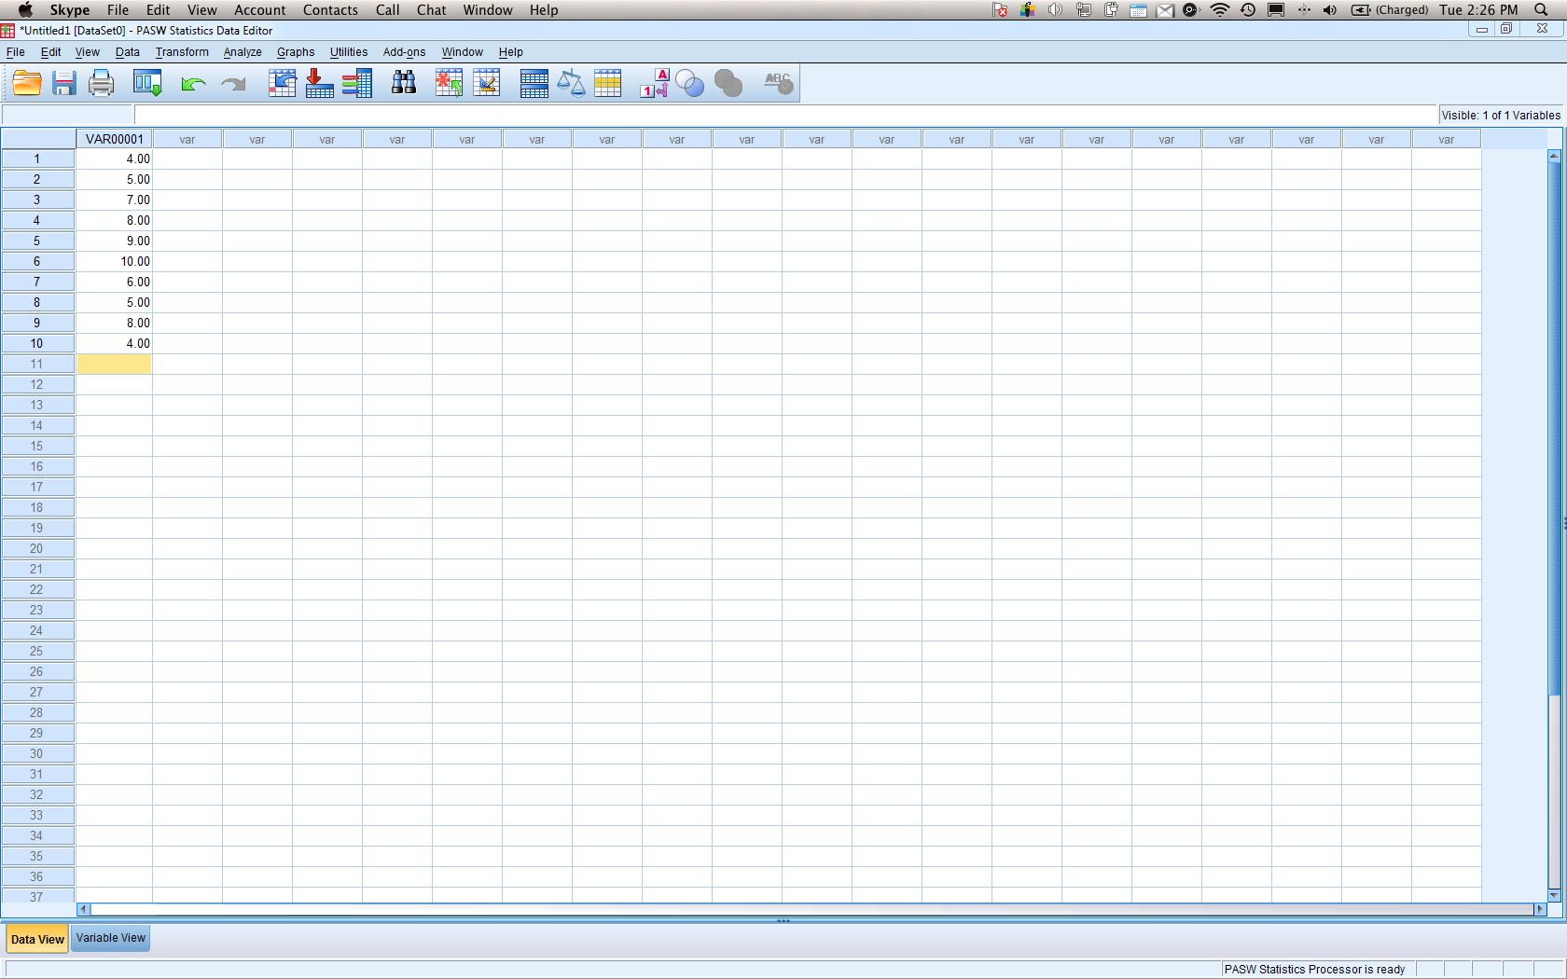
3. Analyze > compare means > one sample t-test.
4. 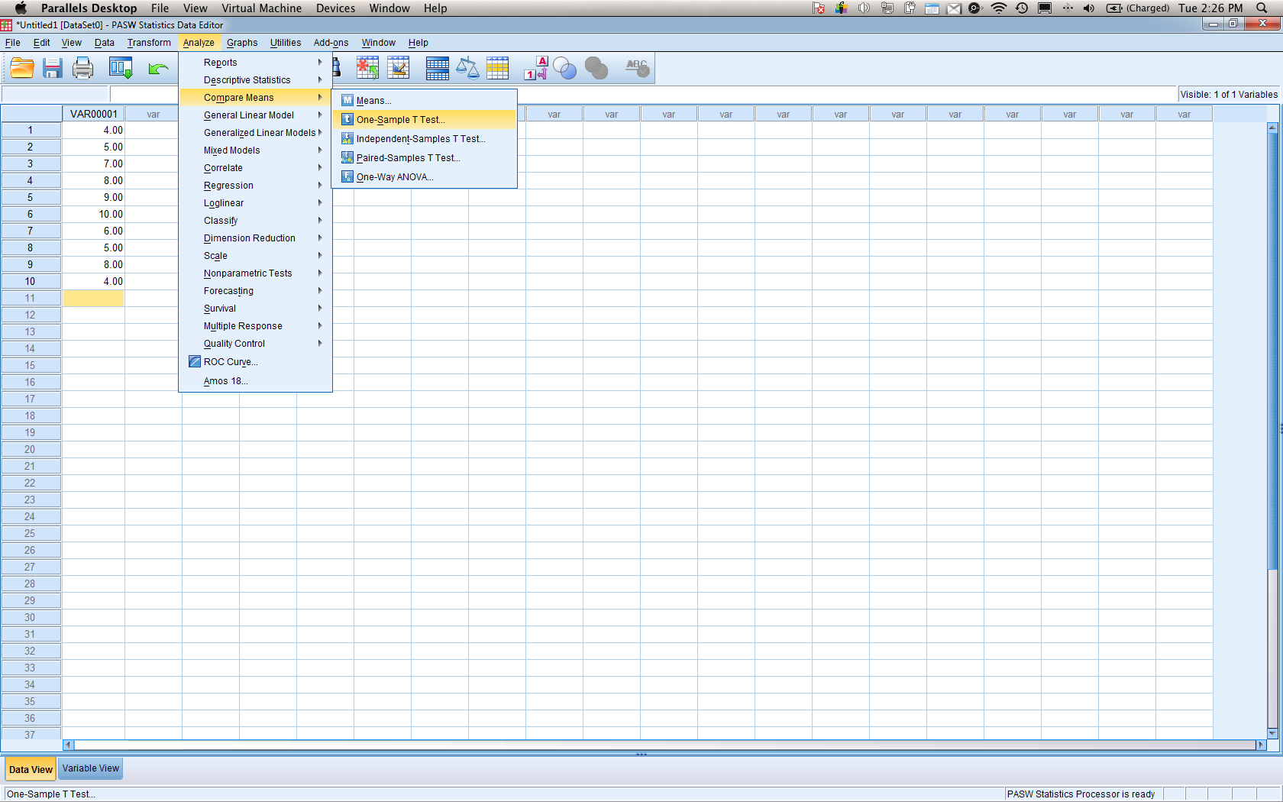
5. Move the variable over to the right side. Also notice on the right side below the variable box it says “test value”.
   1. Put the population mean value in that box. If you forget this step, you will be testing against ZERO, which will not match the problem given.
6. 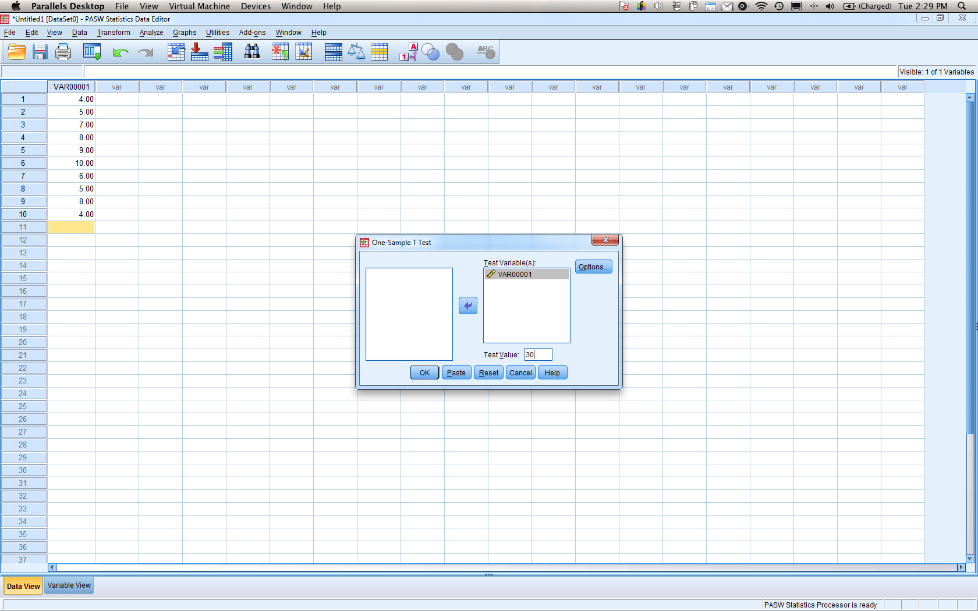
7. Hit ok.

| **One-Sample Statistics** | | | | |
| --- | --- | --- | --- | --- |
|  | N | Mean | Std. Deviation | Std. Error Mean |
| VAR00001 | 10 | 6.6000 | 2.11870 | .66999 |

| **One-Sample Test** | | | | | | |
| --- | --- | --- | --- | --- | --- | --- |
|  | Test Value = 30 | | | | | |
| t | df | Sig. (2-tailed) | Mean Difference | 95% Confidence Interval of the Difference | |
| Lower | Upper |
| VAR00001 | -34.926 | 9 | .000 | -23.40000 | -24.9156 | -21.8844 |

1. Break down of the parts from top to bottom from left to right:
   1. N = number of people in the study.
   2. Mean = sample mean of your people.
   3. Std. Deviation = SD of your sample.
   4. Std. Error of the Mean = Sm – the sample standard deviation of the population.
   5. t = your calculated t-value (step five).
   6. df = degrees of freedom (N-1)
   7. Sig p-value for your study. (if you decide to reject make sure this is less than .05 or .01 depending on the problem.
   8. Mean difference = Sample mean – population mean
   9. 95% CI = upper and lower bound for your CI (for mean difference NOT mean).